Supplementary materials for

**The 2022 Goesan earthquake of the moment magnitude 3.8 along the buried fault in the central Korean Peninsula**

Hobin Lim, Chang Soo Cho, Minkyung Son

Earthquake Research Center, Korea Institute of Geoscience and Mineral Resources, 124 Gwahak-ro, Yuseong-gu, Daejeon, 34132, Republic of Korea

These supplementary materials include 3 Tables for the velocity model used in this study, the outcome of the source spectrum fitting, and the geometrical spreading function; 2 Texts about the moment magnitude and corner frequency estimations; and 7 Figures for events-paring in relocation, detailed outcomes of moment tensor inversion, P wave polarity of events 3 and 30, and the change in the Coulomb Failure Stress for event 30.

**Supplementary Table S1.** The velocity model used to locate the hypocenters.

|  |  |  |
| --- | --- | --- |
| Thickness (km) | *V*P (km/s) | *V*S (km/s) |
| 15 | 5.98 | 3.40 |
| 17 | 6.38 | 3.79 |
| Half space | 7.95 | 4.58 |

Its originality can be found in Kim et al. (2022) and Kim and Kim (1983).

**Supplementary Table S2.** The *f*C and Mw, estimated with the source spectrum fitting.

|  |  |  |  |  |  |
| --- | --- | --- | --- | --- | --- |
| Event | Sta. | *f*C (Hz) | Mw | DIST. (km) | AZ. (°) |
| 3 | CHJ3 | (15.93)a | 3.21 | 8 | 93 |
| 4 | HSB | 3.58 | 3.64 | 117 | 252 |
| 4 | CHS | 2.72 | 3.84 | 120 | 116 |
| 4 | NPR | 6.22 | 3.92 | 130 | 225 |
| 4 | YKB | 3.03 | 3.76 | 150 | 4 |
| 4 | MKL | 2.78 | 3.77 | 177 | 136 |
| 4 | JRB | 3.49 | 3.82 | 186 | 187 |
| 4 | KSA | 5.55 | 3.79 | 195 | 12 |
| 4 | BGD | 3.66 | 4.00 | 325 | 202 |
| 30 | MGB | 8.63 | 2.58 | 41 | 132 |
| 30 | HKU | 7.53 | 2.78 | 55 | 237 |
| 30 | TJN | 8.82 | 2.69 | 72 | 220 |
| 30 | JSB | 10.34 | 2.66 | 87 | 56 |
| 30 | SND | 8.50 | 2.67 | 87 | 69 |
| 30 | SNU | 5.01 | 2.89 | 103 | 308 |
| 30 | HSB | 6.08 | 2.73 | 117 | 252 |
| 30 | CHS | 6.50 | 2.95 | 120 | 116 |
| 30 | YKB | 7.50 | 2.78 | 150 | 4 |
| 30 | MKL | 5.77 | 2.89 | 177 | 136 |
| 30 | JRB | 8.47 | 2.90 | 187 | 187 |
| 30 | HDB | 3.89 | 3.00 | 187 | 133 |
| 30 | YSB | 5.10 | 2.97 | 191 | 145 |
| 30 | GSU | 4.29 | 2.98 | 193 | 174 |
| 30 | KSA | 12.46 | 2.95 | 195 | 12 |
| 30 | HWSB | 6.06 | 3.16 | 229 | 203 |
| 30 | BGD | 9.98 | 3.06 | 325 | 202 |

a: measured with the single station (CHJ3).

**Supplementary Table S3. $g(R,f)$** .

|  |  |  |  |  |  |  |  |  |  |
| --- | --- | --- | --- | --- | --- | --- | --- | --- | --- |
| *R* (km) | *f*= 1.24 Hz | *f* = 1.73 Hz | *f* = 2.23 Hz | *f* = 3.22 Hz | *f* = 5.19 Hz | *f* = 10.13 Hz | *f* = 13 Hz | *f* = 20 Hz | *f* = 30 Hz |
| 10 | 0.477762 | 0.463492 | 0.443639 | 0.524304 | 0.52518 | 0.574503 | 0.638878 | 0.549305 | 0.473399 |
| 15.86 | 0.259168 | 0.204535 | 0.190784 | 0.223371 | 0.221638 | 0.248964 | 0.276299 | 0.232176 | 0.184664 |
| 21.54 | 0 | 0 | 0 | 0 | 0 | 0 | 0 | 0 | 0 |
| 31.62 | -0.22863 | -0.25157 | -0.25327 | -0.26161 | -0.22548 | -0.23701 | -0.22825 | -0.17516 | -0.15517 |
| 46.42 | -0.46082 | -0.45645 | -0.46986 | -0.47656 | -0.43651 | -0.4176 | -0.38168 | -0.2848 | -0.26084 |
| 68.13 | -0.56046 | -0.55737 | -0.58026 | -0.58916 | -0.53257 | -0.43139 | -0.42686 | -0.34011 | -0.32947 |
| 100 | -0.56229 | -0.55814 | -0.56404 | -0.55693 | -0.52582 | -0.46212 | -0.45459 | -0.37338 | -0.3949 |
| 130 | -0.62213 | -0.59395 | -0.60735 | -0.5928 | -0.55886 | -0.49819 | -0.48103 | -0.43197 | -0.44933 |
| 160 | -0.66244 | -0.62354 | -0.64429 | -0.62327 | -0.58541 | -0.54806 | -0.55361 | -0.48999 | -0.51421 |
| 190 | -0.63245 | -0.63397 | -0.6582 | -0.6559 | -0.61901 | -0.58728 | -0.60699 | -0.54038 | -0.56872 |
| 220 | -0.65061 | -0.66516 | -0.67921 | -0.70199 | -0.69456 | -0.62268 | -0.6404 | -0.59783 | -0.61053 |
| 250 | -0.71399 | -0.71879 | -0.73249 | -0.75603 | -0.74704 | -0.68376 | -0.65655 | -0.61566 | -0.6121 |
| 280 | -0.68966 | -0.69802 | -0.74277 | -0.76803 | -0.76198 | -0.71981 | -0.71488 | -0.65467 | -0.63201 |
| 310 | -0.66208 | -0.6934 | -0.73251 | -0.78739 | -0.79328 | -0.75276 | -0.7546 | -0.68329 | -0.6551 |
| 340 | -0.67427 | -0.67968 | -0.70679 | -0.77905 | -0.79765 | -0.74646 | -0.76955 | -0.69694 | -0.6766 |
| 370 | -0.65437 | -0.6899 | -0.71496 | -0.77253 | -0.80093 | -0.76506 | -0.77695 | -0.71023 | -0.69655 |
| 400 | -0.6811 | -0.71947 | -0.73645 | -0.79844 | -0.82643 | -0.81475 | -0.8034 | -0.72949 | -0.69704 |

**Supplementary Text S1.** Estimations of moment magnitude (Mw) and corner frequency (*f*C) based on the grid searching method.

We used absolute of displacement spectrum, *D*(*f*), as in Eq. 1.

|  |  |  |
| --- | --- | --- |
|  |  | (Eq. 1) |

The *D*, *f*, subscripts x, y, and z stand for displacement spectrum, frequency, and cartesian components, respectively, same as Noh et al. (2003). The $\left|D\left(f\right)\right|$ is divided with $exp\left[{-πfR}/{βQ\left(f\right)}\right]$ where $R$ is hypocentral distance in km and $Q(f)$ is

quality factor in Eq. (2) for correcting anelastic attenuation (Yun and Park 2009). The $β$ is shear wave velocity (3.5 km/s).

|  |  |  |
| --- | --- | --- |
|  | $$Q\left(f\right)={292.5f}^{0.53}$$ | (Eq. 2) |

Also, the geometrical spreading function $G\left(R,f\right)$ was corrected based on the modified scheme from Yun and Park (2009). $R_{0}$ is 21.54 km and $R_{1}=128.56+224.00×exp(-f/2.58)$, which is always larger than $R_{0}$.

|  |  |  |
| --- | --- | --- |
|  | $$G\left(R,f\right)=\left\{\begin{matrix}\sqrt{3}R^{-1.23} & \left(R<R_{0}\right) \\ \sqrt{3}{R_{0}}^{-1.23}×{10}^{g(R,f)} & \left(R_{0}≤R<R_{1}\right) \\ \sqrt{3}{R_{0}}^{-1.23}×{10}^{g(R_{1},f)}×{\left(R/{R_{1}}\right)}^{-0.5} & \left(R≥R_{1}\right)\end{matrix}\right.$$ | (Eq. 3) |

The $g(R,f)$ was interpolated from the supplementary Table S3. After the corrections, we had the source spectrum $S\left(f\right)$ in Eq. (4).

|  |  |  |
| --- | --- | --- |
|  | $$D\left(f\right)=S\left(f\right)×G\left(f\right)×exp\left({-πfR}/{βQ\left(f\right)}\right)$$ | (Eq. 4) |

Brune source model (Brune 1970) was fitted to $S\left(f\right)$ as in Eq. 5.

|  |  |  |
| --- | --- | --- |
|  | $$S\left(f\right)=\frac{Ω_{0}}{1+{\left(f/{f_{C}}\right)}^{2}}$$ | (Eq. 5) |

Note that $S\left(f\right)$ goes to $Ω_{0}$ when *f* goes to 0 Hz. The $f_{C}$ is corner frequency. In Eq. 5, we replaced $Ω_{0}$ by the seismic moment $M_{0}$ with Eq. 6.

|  |  |  |
| --- | --- | --- |
|  | $$M_{0}=\frac{4π{ρβ}^{3}Ω_{0}}{〈R_{θϕ}〉F}$$ | (Eq. 6) |

The $ρ$ is density to 2.7 kg/m3. The is averaged radiation pattern of S wave and assumed to 0.63. The *F* is free surface amplification to 2.0. The $M_{0}$ in Nm is described with the moment magnitude (Mw) as Eq. 7.

|  |  |  |
| --- | --- | --- |
|  | $$\log_{10}M_{0}=1.5\left(Mw+10.7\right)-7$$ | (Eq. 7) |

The best-fitting Mw and $f_{C}$ were searched using the grid search. For computational efficiency, we searched limited domains of Mw and $f_{C}$ near the initial values, Mw* and $f_{C}$* (see the supplementary Text S2 for Mw* and $f_{C}$*). The Mw and $f_{C}$ were searched within a range of 0.5 from Mw* with spacing of 0.0125 and a range of 5 Hz from $f_{C}$* (positive only) with spacing of 0.025 Hz, respectively. If the Mw* and $f_{C}$* are unrealistic—that is, $f_{C}$* is above 30 Hz, we searched the Mw in a range of 2.0 from Mw* with spacing of 0.05 and $f_{C}$ in 5–40 Hz with spacing of 0.0875.

**Supplementary Text S2.** Estimations of moment magnitude and corner frequency based on the Snoke method (Mw* and $f_{C}$*).

We first determined the initial values of Mw and $f_{C}$ (Mw* and $f_{C}$*) based on the method of

Snoke (1987) before the grid searching as described in Text S1 in the supplementary materials. Based Eqs. 8 and 9, we began to obtain the *J* and *K*.

|  |  |  |
| --- | --- | --- |
|  |  | (Eq. 8) |
|  |  | (Eq. 9) |

The $ω$ is angular frequency ($ω=2πf$). We set optimal *f*1 and *f*2 for each pair of event and station, for including the *f*C between *f*1 and *f*2. The same *f*1 and *f*2 were used in the grid searching domain (Text S1 in the supplementary materials). The $Ω_{0}$ is initially guessed as $D\left(ω_{1}\right)$ (Jo and Baag 2001). After the *J* and *K* were obtained using Eqs. 8 and 9, the $Ω_{0}$ was updated using Eq. 10.

|  |  |  |
| --- | --- | --- |
|  | $$Ω_{0}={\left[\frac{4K^{3}}{J}\right]}^{1/4}$$ | (Eq. 10) |

With the new $Ω_{0}$, we recalculated the *J* and *K*. We performed this iteration by 50 times with updating *J* and $Ω_{0}$, as Jo and Baag (2001).

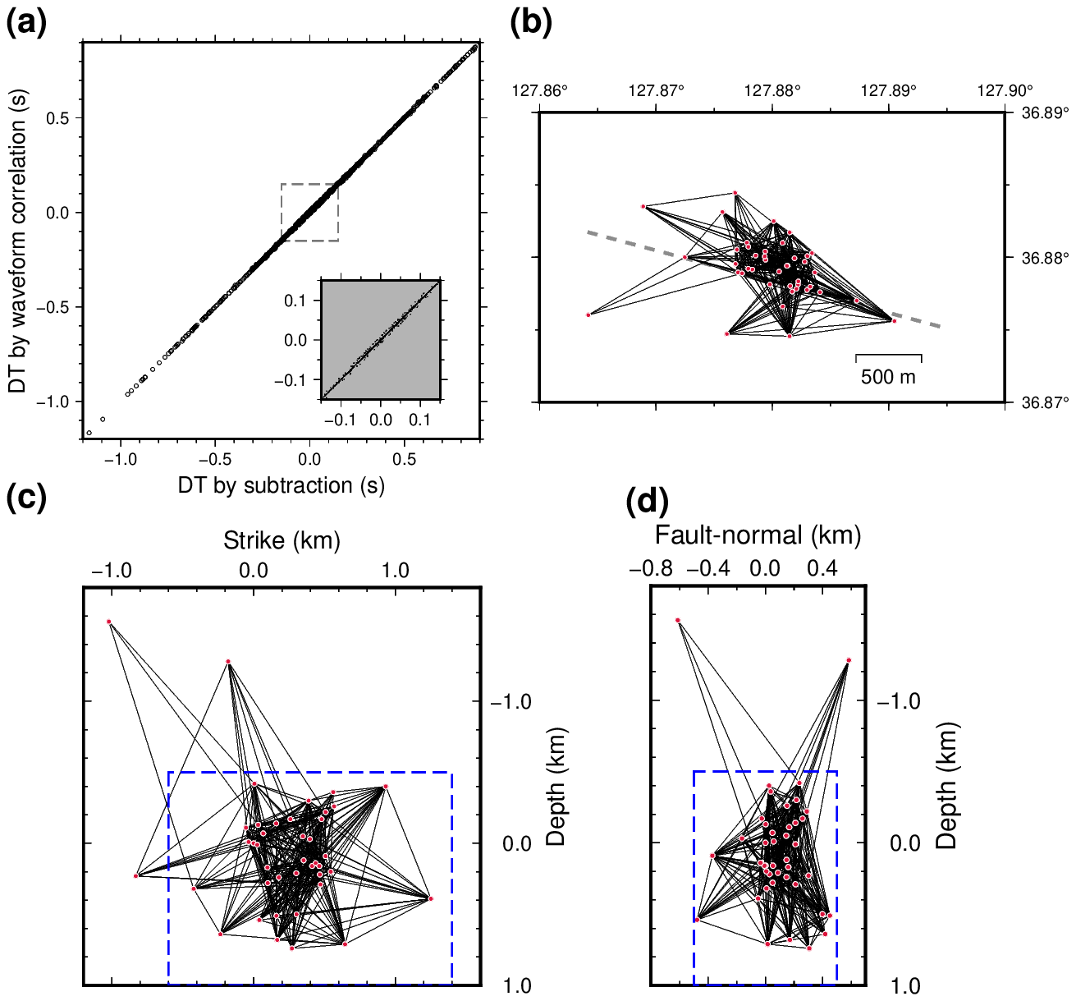

**Supplementary Fig. S1.** Pairs of the earthquakes for the double-difference relocation. (a) Comparison between the differential times measured by the waveform cross-correlation and subtraction of the manually selected P and S wave arrival times. Inset shows the magnified domain in −0.15–0.15. (b) Pairs in map view. (c) Pairs in fault-plane view. (d) Pairs in fault-parallel view. DT: differential time measured. The dashed boxes in (c) and (d) are the domains of Fig. 5b and c, respectively.

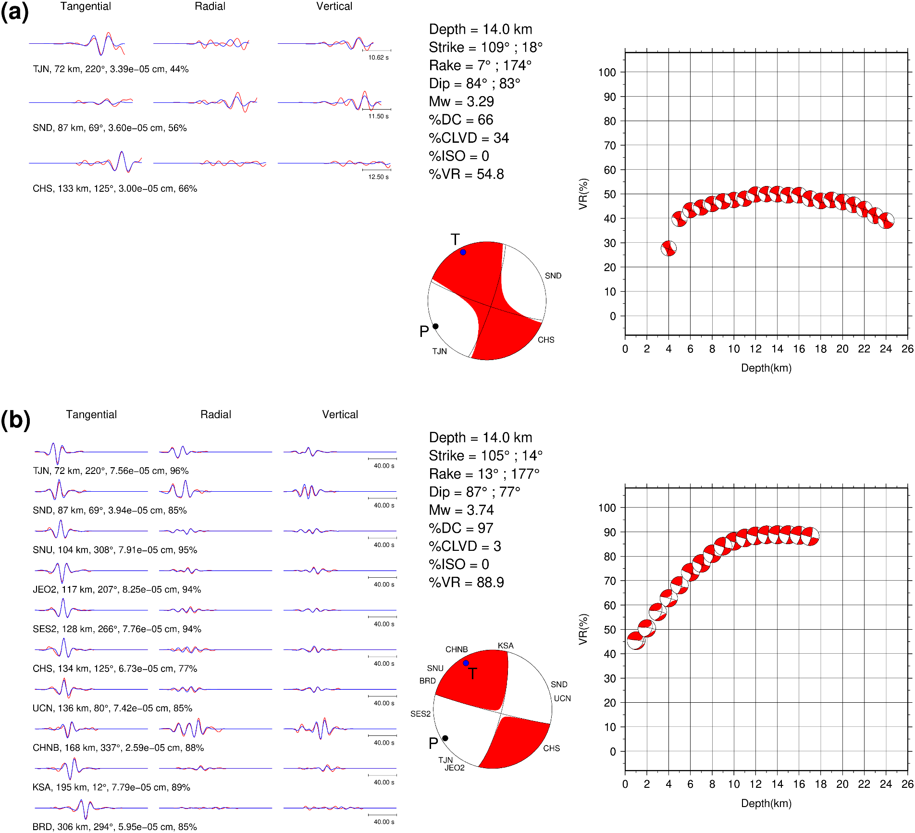

**Supplementary Fig. S2.** Moment tensor inversions. (a) Mw 3.3 foreshock (event 3). (b) Mw 3.8 mainshock (event 4). Red and blue traces are observed and synthetic waveforms, respectively. Station name, distance, azimuth, maximum amplitude, and variance reduction are shown at the bottom of each trace. VR: variance reduction. DC: double couple component. CLVD: compensated linear vector dipole component. ISO: Isotropic component.

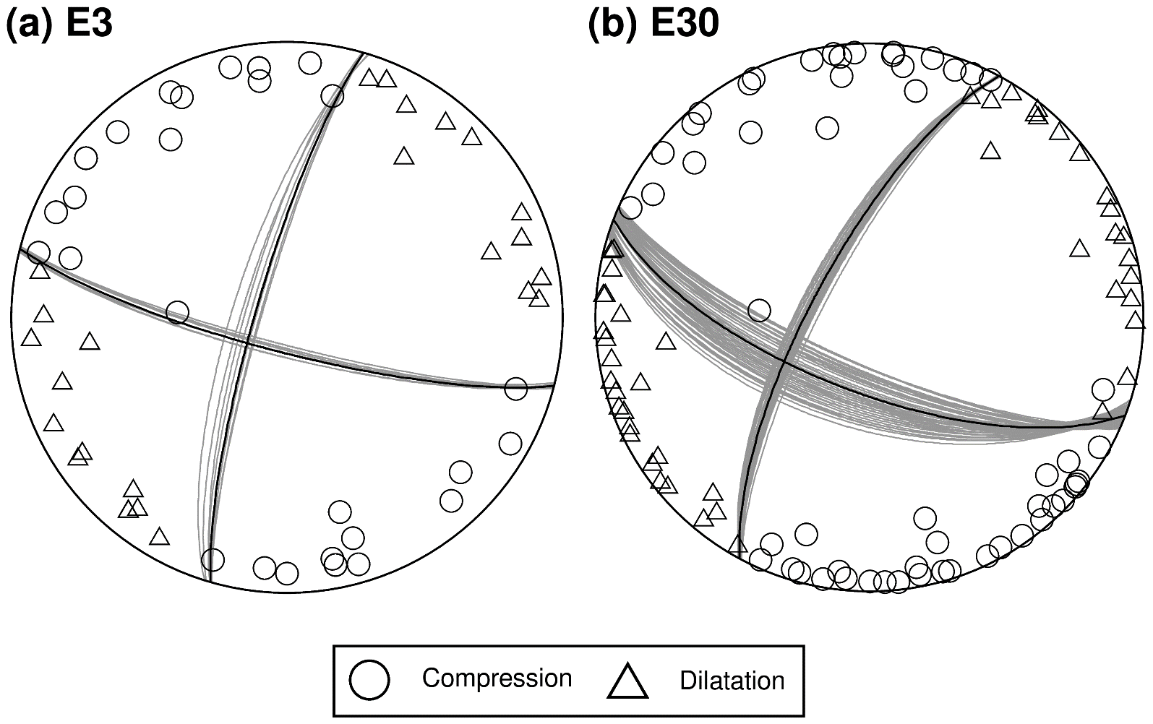

**Supplementary Fig. S3.** Polarity of the P wave, constraining the focal mechanism for (a) events 3 and (b) event 30. Grey great circle indicates nodal planes of all solutions meeting the polarity with one outlier. The best solution is plotted as a black great circle.

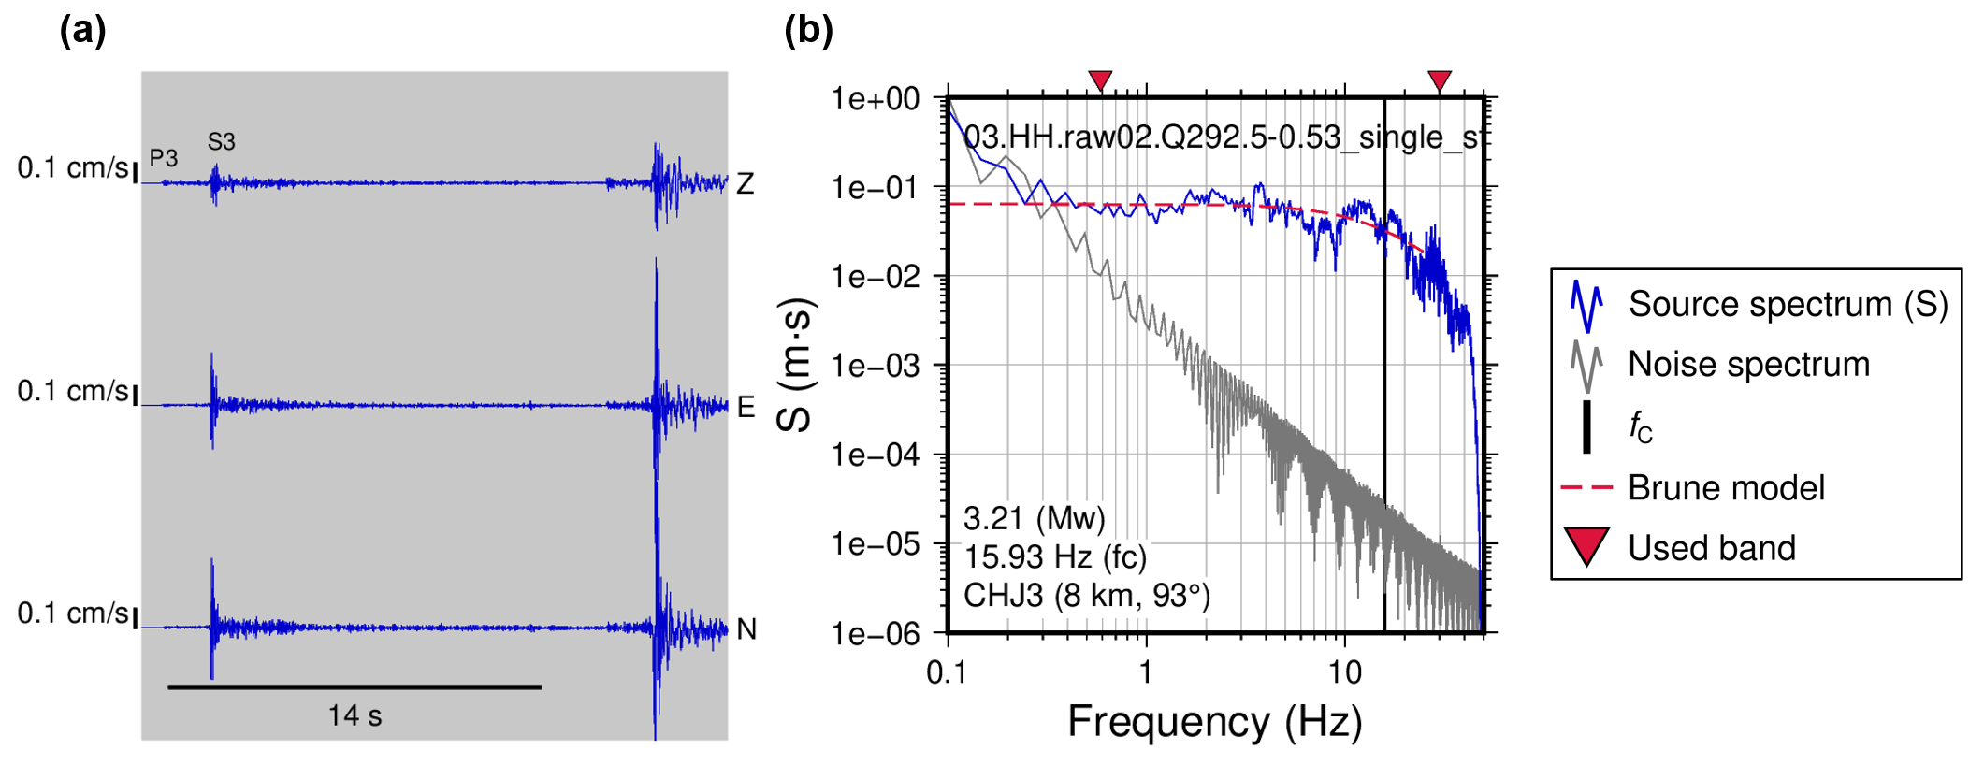

**Supplementary Fig. S4.** Source spectrum fitting for event 3. (a) Used window of the station CHJ3 with a length of 14 s. P3 and S3 denote P and S arrivals of event 3. Following waveforms are those of the mainshock with a temporal gap of the origin time by 17 s. (b) Single station spectrum fitting.

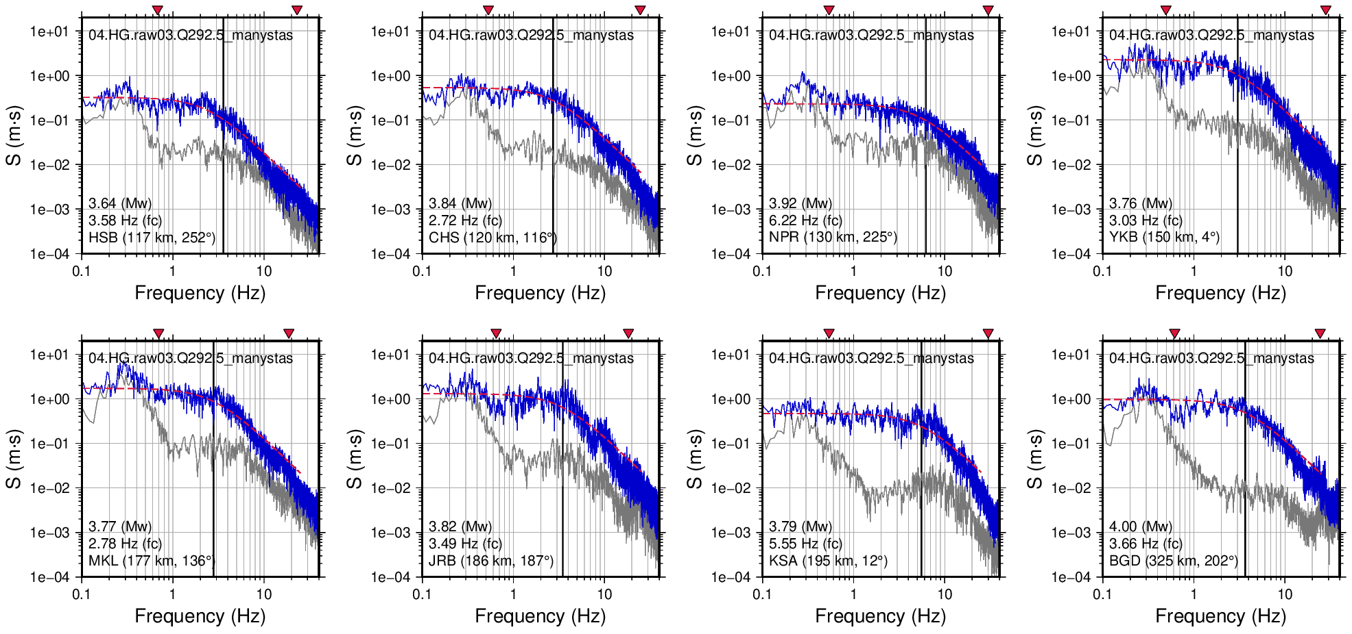

**Supplementary Fig. S5.** Source spectrum fitting of event 4.

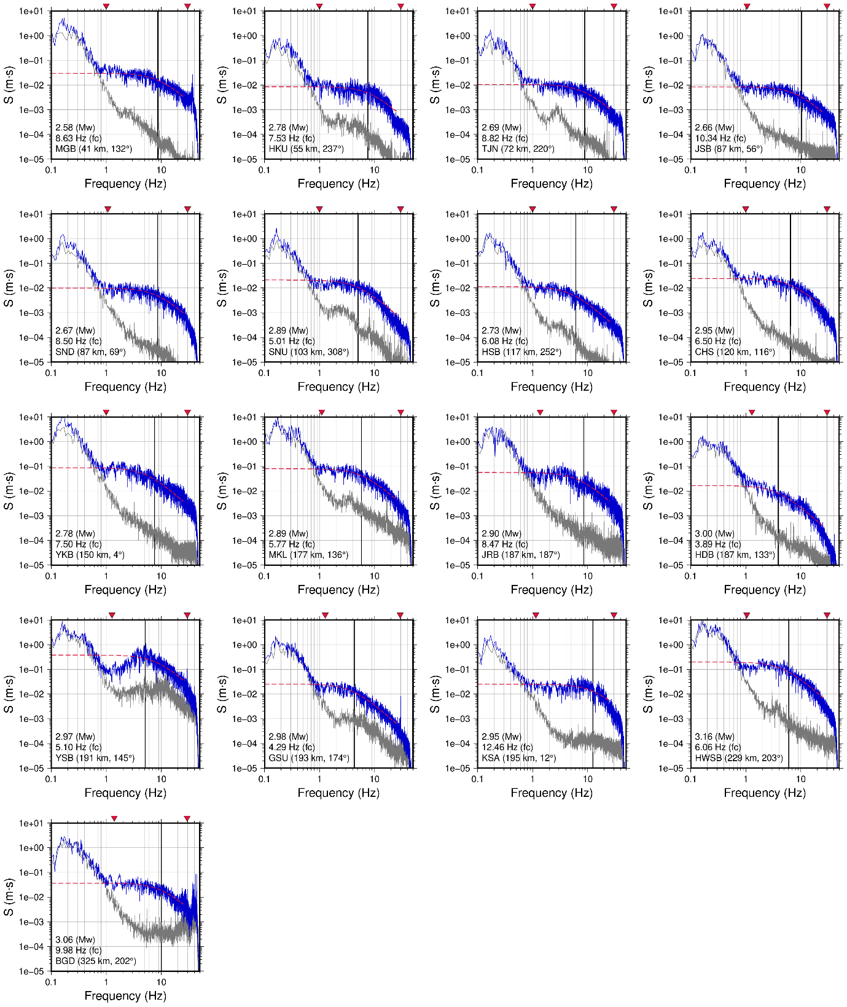

**Supplementary Fig. S6.** Source spectrum fitting of event 30.

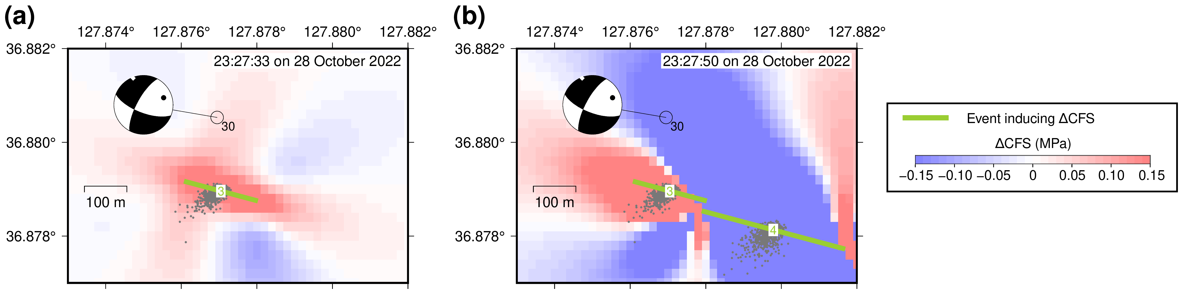

**Supplementary Fig. S7.** Change in the Coulomb Failure Stress (ΔCFS) of the Mw 3.3 foreshock (event 3) and Mw 3.8 mainshock (event 4). The strike, dip, and rake of the receiver fault are 111°, 68°, and −19°, respectively, targeting event 30. (a) ΔCFS of the Mw 3.3 foreshock. (b) ΔCFS of the Mw 3.8 mainshock, added to the previous snapshot in (a). Perturbed relative locations of events 3 and 4 are shown with grey dots.

**References**

Brune JN (1970) Tectonic stress and the spectra of seismic shear waves from earthquakes. Journal of Geophysical Research (1896-1977) 75:4997–5009. <https://doi.org/10.1029/JB075i026p04997>

Jo ND, Baag CE (2001) Stochastic Prediction of Strong Ground Motions in Southern Korea (written in Korean with English abstract). Journal of the Earthquake Engineering Society of Korea 5:17–26

Kim SJ, Kim SG (1983) A study on the crustal structure of South Korea by using seismic waves. J Korean Inst Mining Geol 16:51–61

Kim W-Y, Park JY, Seo M-S, et al (2022) The 14 December 2021 Mw 4.9 Offshore Jeju Island, Korea, Earthquake: Seismological Observation of an Intraplate Earthquake Provides Insight into Regional Seismotectonics. The Seismic Record 2:107–117. <https://doi.org/10.1785/0320220012>

Noh M, Choi K-R, Kim T-K (2003) Analysis of Fourier Amplitude Spectrum by Composing 3-component Seismic Records (written in Korean with English abstract). Journal of the Korean Geophysical Society 6:25–29

Snoke JA (1987) Stable determination of (Brune) stress drops. Bulletin of the Seismological Society of America 77:530–538. <https://doi.org/10.1785/BSSA0770020530>

Yun K-H, Park D-H (2009) Nonparametric ground-motion evaluation of high frequency shear-wave Fourier spectra in Korea. Geosci J 13:387–399. <https://doi.org/10.1007/s12303-009-0035-z>